**Assignment – 2**

1. Write the Algorithm and draw the flowcharts for the following
2. Print even numbers between 0 and 99

Step 1: Start

Step 2: Number=0, count=0

Step 3: Read next number

Step 4: Count=count+1

Step 5: If number % by 2,if not go to step 3

Step 6: Print the number, check count<=99

Step 7: Stop

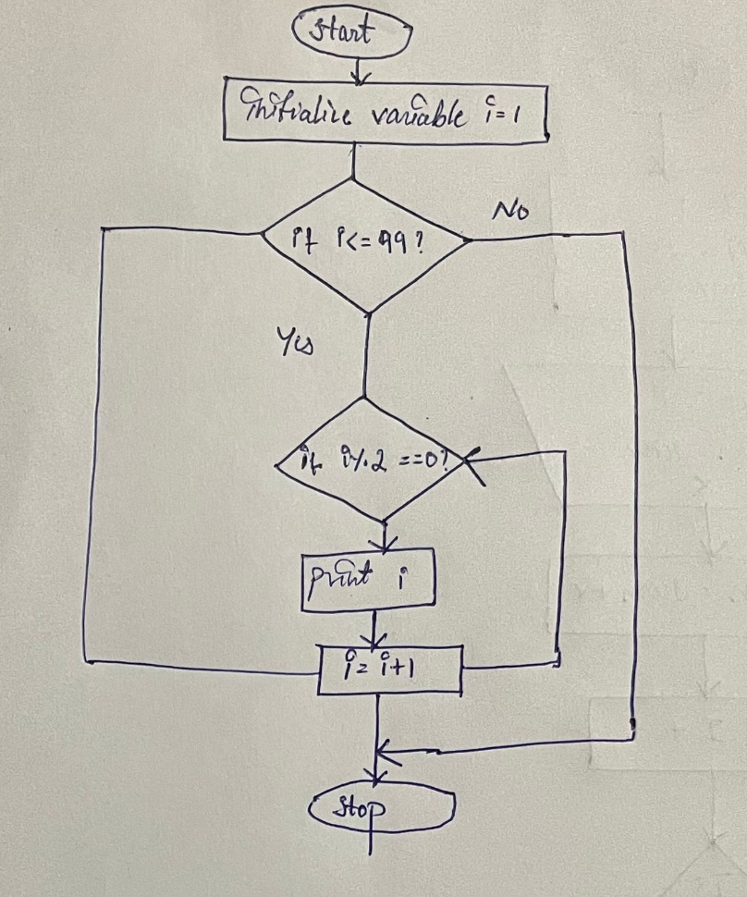

1. Print odd numbers less than a given number. It should also calculate their sum and count

Step 1: Start

Step 2: Declare variable c of integer type

Step 3: Set c=0

Step 4: Repeat step 5 to 7 while (c<=100)

Step 5: if (c%2 != 0)

Step 6: then print c

Step 7 : c=c+1

Step 5: Stop

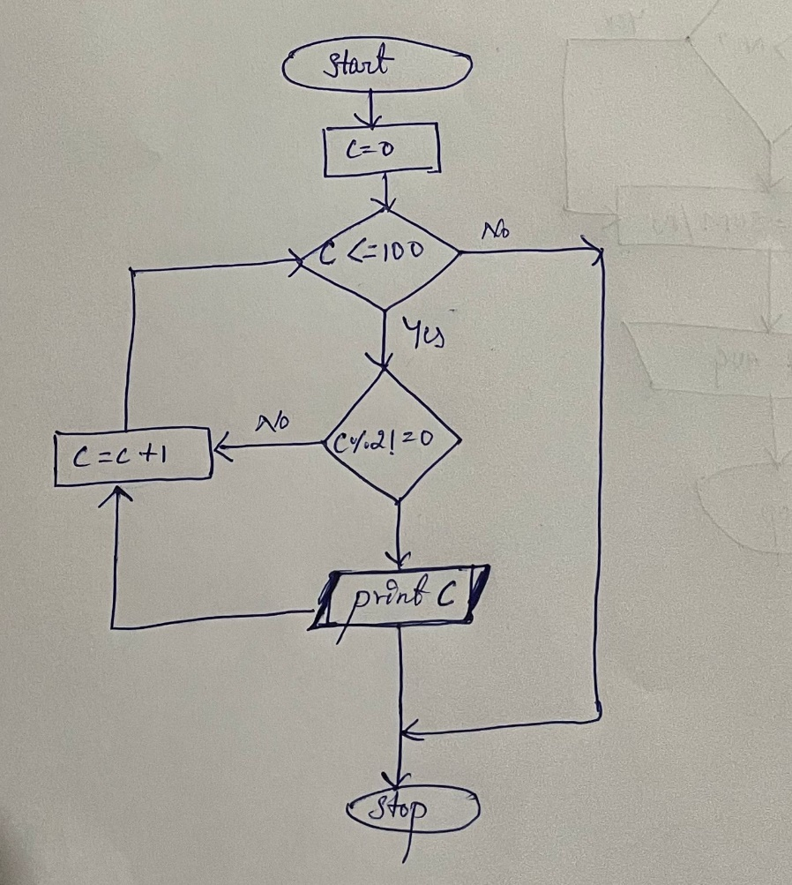

1. Calculate the average of 25 test scores

Step 1: Start

Step 2: Read Sum = 25

Step 3: input four numbers A, B, C and D

Step 4: sum = A+B+C+D

Step 5: Display sum

Step 6: stop

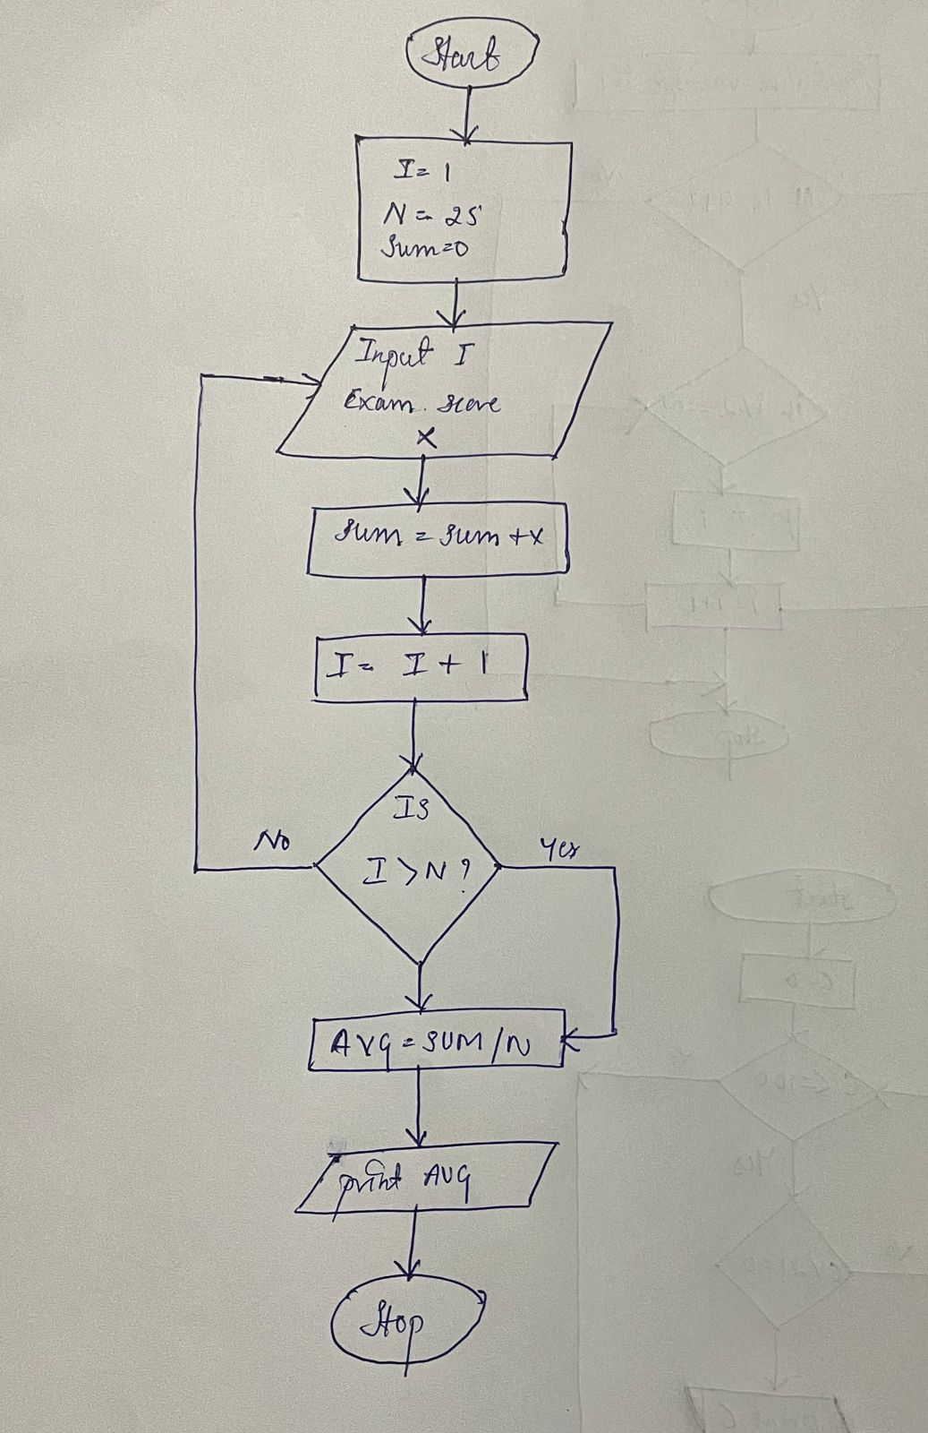

1. Print table of any number N (say 7)

Step 1: Start

Step 2: Input a number for which the multiplication table is to be printed.

Step 3: assign the end value where **end=7**

Step 4: Repeat from **i=1** to end

Step 5: Display the table values in the given output format. **(num*i = num*i)**

**Step 6: Stop**

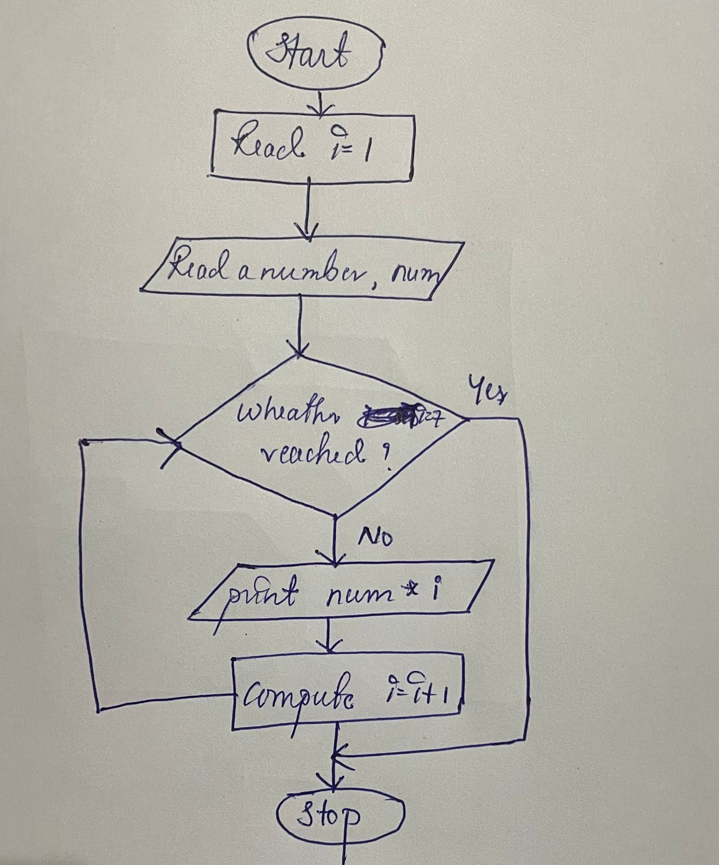

1. Check if the given number is Prime or not

Step 1: Start

Step 2: Read number n

Step 3: Set f=0

Step 4: For i=2 to n-1

Step 5: If n mod 1=0 then

Step 6: Set f=1 and break

Step 7: Loop

Step 8: If f=0 then

print 'The given number is prime' else print 'The given number is not prime'

Step 9: Stop

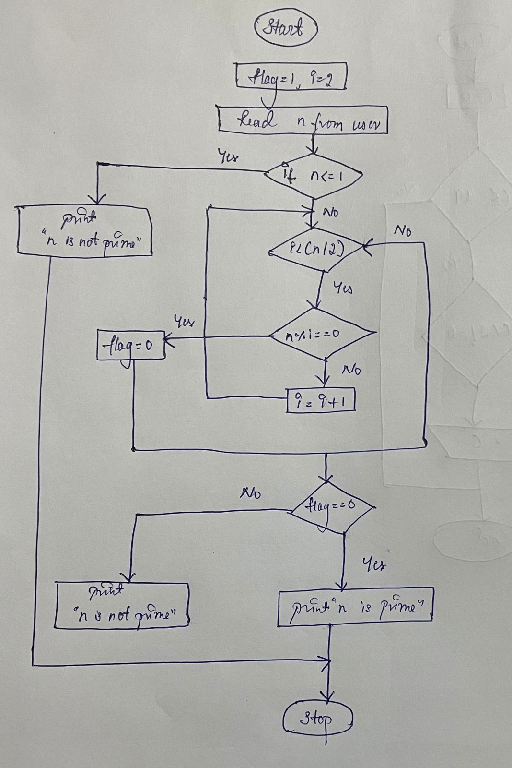

f) Print odd numbers backward from 99 to 1

Step 1: Start

Step 2: Assign i=0

Step 3: Repeat steps 4,5&6 until i=99 reaches

Step 4: If i%2!=0 goto step 5

Step 5: Print i

Step 6: Compute i=i+1

Step 7: Stop

